#include <stdio.h>

int main()

{

int number;

printf("Enter an integer: ");

scanf("%d", &number);

if (number%2 == 0)

{

printf("%d is an even integer.",number);

}

else

{

printf("%d is an odd integer.",number);

}

return 0;

}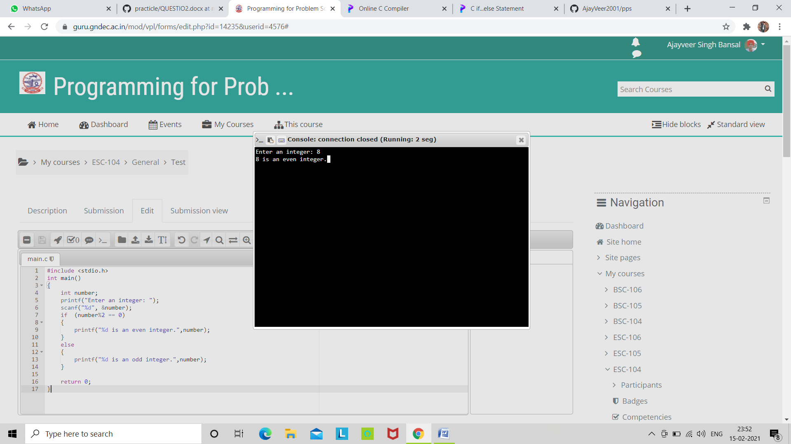

#include <stdio.h>

int main()

{

int number1, number2;

printf("Enter two integers: ");

scanf("%d %d", &number1, &number2);

if(number1 == number2)

{

printf("Result: %d equals to %d",number1,number2);

}

else if (number1 > number2)

{

printf("Result: %d greater than%d", number1, number2);

}

else

{

printf("Result: %d smaller than %d",number1, number2);

}

return 0;

}

